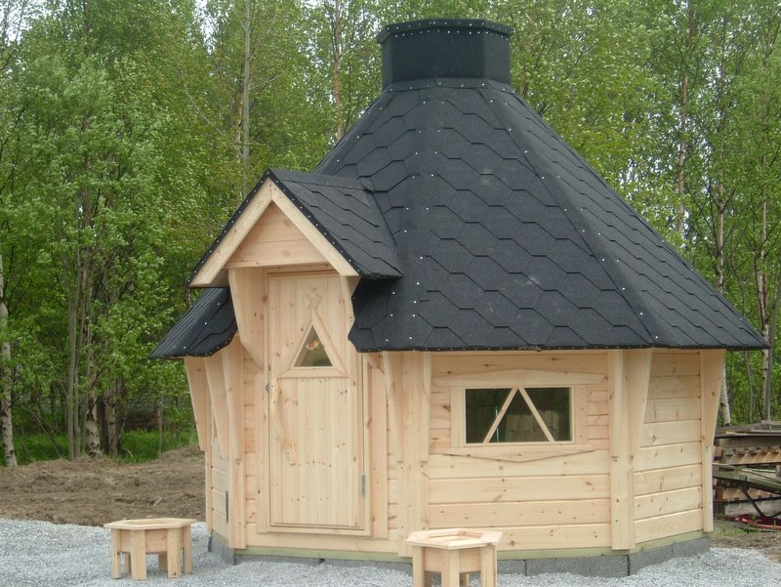 | 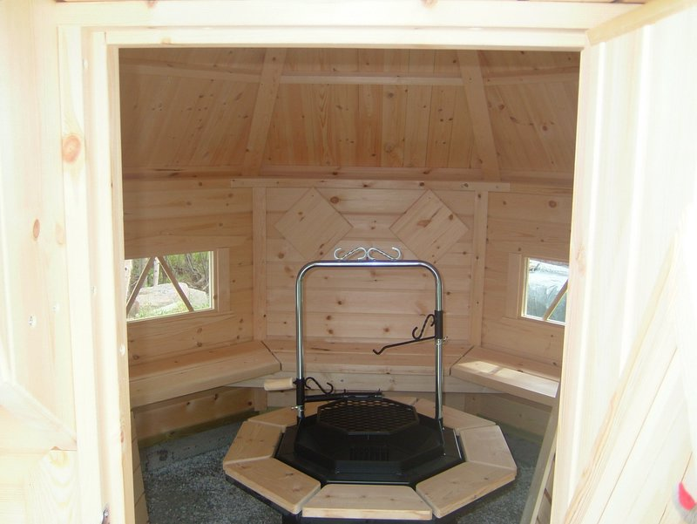
 | 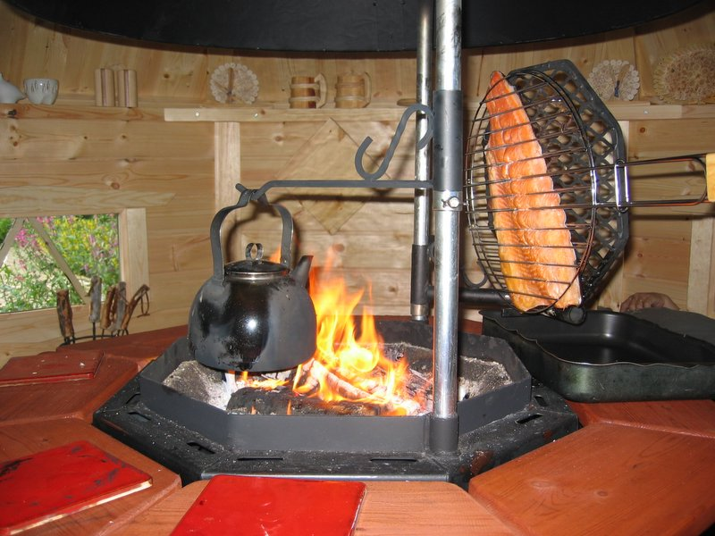
 | 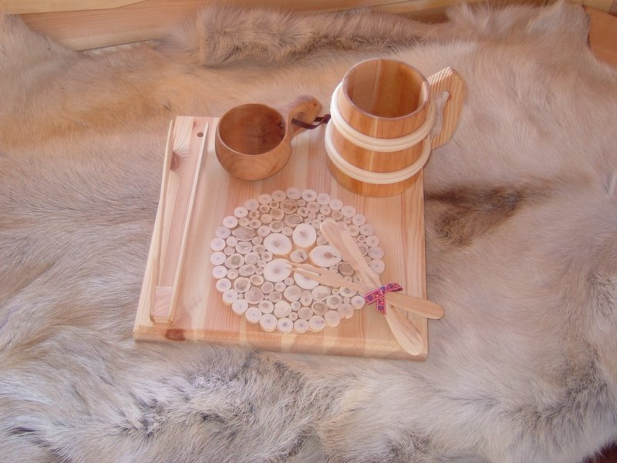
Finnish BBQ Hut 6.9 m² – £4,800
Octagonal – Seating for 8 persons
Roof projection: 0.37 m

Consists of:
Walls: 40 mm double tongue and groove logs from Red Pine.
Flooring: Decking that can be removed for cleaning.
Roof: 20 mm tongue and groove roof boards.
Doors: 1 door
Windows: 4 windows, double glazed

Included Equipment:
An octagonal grill Bottle binoculars
A round table around the grill Striped wooden mugs
A grill set A bottle opener
A brick pan Juniper underlay
A steel kettle A leather coffee bag
Reindeer skins Reindeer horn exact
A coffee pot warmer Toggle tables
A pillow A pot mitten and patches
Santa Claus A thermometer
A visitors book An axe block
Wood cups A fillet knife
A pan watch Fork and knife sets
A Lapp knife A jingle bell
A four-cornered hat and scarf A Lapp willow grouse
Juniper bun dishes A reindeer paw
Juniper servers Flower boxes

Extras:
Larger windows Call for price
Smoke stack Call for price
Build Call for price
 | 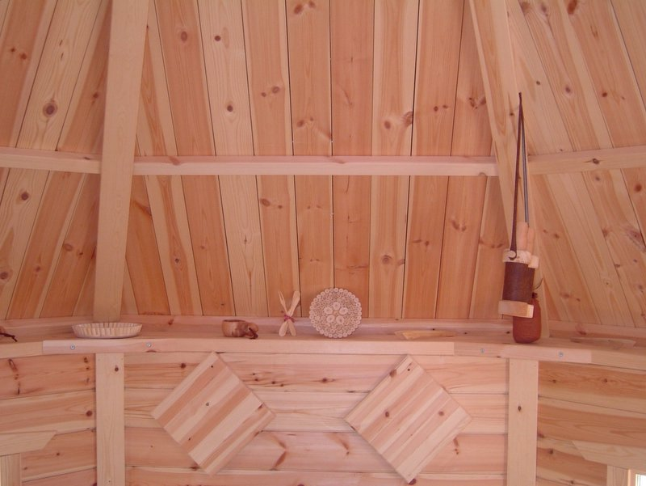
 | 